Motor Vehicle Record System

Jordan Moore, Kyle Randall, Kue Khang, Bill Vang, Anton Fuchs

Table of Contents

[Letter of Introduction 2](#_Toc6564599)

[Team Description 3](#_Toc6564600)

[Description of Customer/Client 6](#_Toc6564601)

[System Request Form 7](#_Toc6564602)

[Fact-Finding Preparation 8](#_Toc6564603)

[Results of Fact-Finding 10](#_Toc6564604)

[Project Scope and Recommendations 12](#_Toc6564605)

[Project Schedule 13](#_Toc6564606)

[Feasibility Analysis 14](#_Toc6564607)

[Data Flow Diagrams 16](#_Toc6564608)

[Data Flow Diagram Legend 16](#_Toc6564609)

[Context Diagram 17](#_Toc6564610)

[Diagram 0 18](#_Toc6564611)

[Child Diagrams 19](#_Toc6564612)

[Decomposition Diagram 20](#_Toc6564613)

[Data Dictionary 21](#_Toc6564614)

[Entity Relationship Diagram 22](#_Toc6564615)

[CRUD Matrix 23](#_Toc6564616)

[Wireframes 24](#_Toc6564617)

[Security Authorization 26](#_Toc6564618)

[Appendix A – Resumes 27](#_Toc6564619)

# Letter of Introduction

To:   
*Federated Insurance*   
*121 E Park Square*   
*Owatonna, Minnesota*   
*March 1, 2019*   
  
*To Whom It May Concern,*   
  
My name is Jordan Moore and I would like to take this opportunity to briefly introduce myself and my team for your Motor Vehicle Record system analysis & design. We are a group of hard-working individuals, each with unique capabilities that when combined bring together a great team.   
  
**Meet Our Team:**   
Jordan Moore, our Project Manager, has years of experience managing projects in order to ensure the project goes smoothly and all questions are answered in a timely fashion. Jordan will work hard to ensure that your project stays within budget and time constraints.   
  
Kyle Randall, our Senior Developer, has years of experience in database design & implementation, front end development, and backend scripting.   
  
Anton Fuchs, our Junior Developer, brings to us new experiences and ideas. Anton will be working alongside Kyle to bring the project to life!   
  
Bill Vang, our Documentation Specialist, brings years of documenting systems throughout his various roles and will be providing the best documentation possible for your system.   
  
Kue Khang, our Data Entry specialist, brings years of data entry to the table and has "Wack" typing skills. This will allow us to turn your project around as fast as possible.   
  
We are excited & looking forward to the prospect of completing this project alongside your company to ensure the best results for both us & your company! I look forward to speaking with you throughout the course of this project!   
  
*All the Best,*   
Jordan Moore   
Project Manager

# Team Description

|  |  |
| --- | --- |
|  | **Jordan Moore**  Project Manager   Jordan has years of experience managing projects in order to ensure the project goes smoothly and all questions are answered in a timely fashion. Jordan will work hard to ensure that your project stays within budget and time constraints. |
|  | **Kyle Randall**  Senior Developer   Kyle has years of experience in database design & implementation, front end development, and backend scripting. |
|  | **Anton Fuchs**  Junior Developer   Anton brings to us new experiences and ideas. Anton will be working alongside Kyle to bring the project to life! |
|  | **Bill Vang**  Documentation Specialist   Bill brings years of documenting systems throughout his various roles and will be providing the best documentation possible for your system. |
|  | **Kue Khang**  Data Entry specialist   Kue brings years of data entry to the table and has some amazing typing skills. This will allow us to turn your project around as fast as possible. |

# Description of Customer/Client

**Detailed summary of the company or division requesting project. This includes things to help you understand the purpose, vision and values.**

Federate Insurance would like the requesting project to focus on (MVR) motor vehicle report. Reviewing all applications from prospective clients and periodically re-evaluating current clients’ accounts. Build a system which will automatically order motor vehicle reports and ability to monitor the drivers and implement a list of drivers who are on a policy.

**Company description (Who are they? What do they do?)**

The company began offering life insurance, workers compensation coverage, group health insurance, estate planning services, and a variety of risk management tools.

**List of products offered by Federated Mutual Insurance Company:**

* Commercial Property and Casualty insurance
* [Life](https://en.wikipedia.org/wiki/Life_insurance), [disability](https://en.wikipedia.org/wiki/Disability_insurance), and [critical illness](https://en.wikipedia.org/wiki/Critical_illness_insurance) insurance
* [Home](https://en.wikipedia.org/wiki/Home_insurance) and [auto](https://en.wikipedia.org/wiki/Vehicle_insurance) insurance
* Workers Compensation

Federated once offered group [health insurance](https://en.wikipedia.org/wiki/Health_insurance), but ceased this offering at the end of 2017.

**Organizational chart of the company or employees who will use the system**

The underwriter will use the system and to get reports to either accept a driver or decline.

**Other relevant background information available.**

Federate became among the nation’s first multiline insurance companies with our expansion into liability coverage. Federate continues growing, stepping into life insurance, workers compensation coverage, group health insurance, and estate planning services. By the end of the 20th century, Federate were among the largest mutual insurance companies in the nation. Federated started in Owatonna, a small city in southern Minnesota and servers many customers as much as 49 states.

# System Request Form

Name:

Automated Motor Vehicle Report System

Sponsor:

Brian Carlson

<Department Unknown>

Federated insurance

<Phone Unknown>

<Email Unknown>

Business Need:

In order to better serve clients, increase efficiency, and more accurately assess risks, an updated system for acquiring Motor Vehicle Reports is hereby requested to be created. Federated Insurance has the opportunity to sponsor the development of a new, comprehensive method for handling MVRs and the information they provide. The system should allow for clients to manage their driver list, and should also ensure that Processors are only notified if a MVR comes back with an event that would impact the policy and rate.

Functionality:

1. Provides scheduled MVRs to Federated for all drivers on insurance plans
2. Resolves MVRs that do not impact a policy without involving an underwriter or processor.
3. Allows clients to manage the list of drivers on their policy

Expected Value:

If implemented, this plan would be able to alert Federated and the client of a driver having been involved in a car accident. It would also theoretically decrease the cost of keeping MVRs up-to-date, and would indirectly decrease the number of accidents involving drivers for companies insured by Federated, as this new system would help to drum out drivers with a problematic record.

Special Issues & Constraints:

* We will not have access to the data in question and cannot optimize the system for it.
* The system will not be tested for function as we will not be ordering real MVRs
* Because of the way the semester has played out already, we will be crunched for time when it comes to development.

# Fact-Finding Preparation

1. What are some challenges that you have with the system?
2. How much people use the system daily?
3. What is the reason for changing the system?
4. What have you tried so far to upgrade the system?
5. What is the cost budget that you are looking into putting in the system?
6. Who is using the system?
7. Are there different levels of access that some people will need?
8. What are you looking for in the system?
9. Are you looking for a system that is easier to understand or more function in the system?
10. Is equipment outdated or is cost of equipment an issue?
11. What kind of software are you using in the system?
12. Who are the end users using the application?
13. How soon do you need this project to be done?
14. What is the budget for this project?
15. How old is the application overall?
16. Does different states or city affect how the system should be used?
17. What are the biggest challenges and risk in this business?
18. Who is your competitor and how can we impact the results of helping end users and consumers?
19. Who is the system or application used for? Consumers or end users?
20. How do you know if this project will be needed in the future?
21. What has change in your business’s needs?
22. Are we moving any information or data to the new application that will moved to the system?
23. What are your expectations? And if it is not what your expectations are? How can we communicate and come to an understanding?
24. How has the new nature of the US job market impacted employee turnover?
25. Given the increasing number and scope of corporate data breaches, what is Federated Insurance doing to protect client data? What systems (without going into too much detail) are in place?
26. How has your company adapted to the evolving IT market?
27. Why did Federated buy up the Mankato Verizon call center?
28. Are there more needs for technical development on the business side or the client side?
29. What can be done to improve and streamline insurance claims to better aid clients?
30. What expansions are being planned to protect clients from data theft?
31. What sort of corporations/clients does Federated provide insurance for, and what is it protecting them from?
32. With Federated being responsible for paying insurance claims for automotive industry, what (if anything) is Federated doing to improve vehicle safety?
33. What level of automation is currently being implemented for claims?
34. What plans are currently in place for automation?
35. How does the IT department handle claims?

# Results of Fact-Finding

**Current System**

The current system gives the businesses new functions and flexibility to order and view MVRs, Driver lists and Driver summary.

Some function and flexibility include:

* Sending and receiving MVRs during the day
* Friendly view of driver information
* Comment can be stored with MVRs
* Underwriters and Processors can view up to date drivers list online
* Linking Driver’s Evaluation Summary to MVRs
* Avoid data duplication of information when storing into the system

In order to implement the current system to the old system, the project was separated into phase.

* **Initiation Phase** – Developing the workplan or the process of initiating the system
* **Analysis Phase** – Gather information needed for development, refinement of entity relationships, Gather requirements for development
* **Design Phase** – Design Data design, Architecture design, Program designs, and the Screen design
* **Construction Phase** – Create the code for the system
* **Testing Phase** – Test the system to find problems
* **Implementation Phase** – Figure out ways to train and implement the system
* **Review Phase** – Monitor the system activity

The staffs that was involved:

* Executive Sponsors, Project Sponsors, Business Project Manager/Expert, IS Project Manager, and Account Manager

**New Modified System**

The new functionality desired in the new modified system will include:

* End user access
* Automatically order MVRs
  + If it’s a brand-new driver, the MVR is ordered when the driver is in the system
* Monitor Driver
* Keep list of drivers and policy
* Description of users and authority they should have to each part of the system
* Keep record of violations within the month
* If no violation, then don’t order
* Ability to override the frequency of ordering MVRs

Data that should be captured are ordering of MVR from IIX or choice point. The cost of MVR is $6 - $10 when ordered from IIX. Other data that should be included are information input from the end user such as comments about the drivers.

Detail about reports or screen display output needed and who should have access to view/print

The Underwriter would need access to view the MVRs

Any hardware-related constraints

# Project Scope and Recommendations

Federated Insurance would like to create a project focused on the managing and monitoring of motor vehicle reports (MVR). This will be achieved by developing a web application that order's MVR's automatically, alerting underwriters of violations that have occurred for a driver under their client's policy, and should allow clients to enter driver information to check if they are eligible for insurance. Underwriters will have a more comprehensive system to manage their book of business and clients will be able to view and update their drivers' information.

The application will contain the following features:

Form for clients to enter driver information and edit existing driver's information.

Forms to allow underwriters to add and edit driver and client information.

Forms to allow underwriters to edit the rules for the automated MVR ordering.

Forms for processors to manage users, MVR ordering, and view errors.

Reports for underwriters to view all drivers in their book of business that have violations on their MVRs.

The ability to order MVR's automatically when given driver information. This will allow automation of MVR ordering. The system will be able to order MVR's using the driver information entered by clients or underwriters as well as predefined rules for ordering MVR's per state. Each month a $0.06 check will be done to see if there are any new violations for a driver, orders a full MVR for $6-$10 if there is a violation and alerts the assigned underwriter. Depending on the frequency set for the driver, a full MVR will be ordered every 1 month to 2 years, with underwriters allowed control over setting this frequency. Also, the system will save information on drivers such as name, license, and the policy they are under, it will also save records of MVRs for each driver. This application will be web based and is planned to run on a LAMP stack, underwriters and clients will be given a web interface to access the system. Finally, the system will need to limit access to MVR's as there are privacy laws that prevent that information from being shared with clients and parties other than Federated Insurance.

# Project Schedule



# Feasibility Analysis

As it stands, Federated Insurance’s current MVR system is not comprehensive enough for their needs. There is no automation, clients are not well tracked, and potentially dangerous drivers are insured when an MVR could have prevented that. This recommended project comes with numerous advantages that will outweigh the costs of creating and running this new system.

This project is operationally feasible, and has the backing of management, who are prepared to commit the appropriate resources to this project. Dedicated underwriter and processor views will allow for a more efficient, comprehensive experience for employees. However, it will take time to train the new users and they may experience lower productivity during this period. Automated MVR monitoring and ordering will decrease costs of operations, but may result in a decrease in the processors workforce. Client companies gain the added (and requested) bonus of being able to more closely monitor their drivers and assess prospective drivers through the customer portal. However, they may also experience frustration with their employees no longer being eligible for insurance after a series of violations. A database driven web application is one of the most feasible solutions to improving the Federated MVR system due to a need for central data storage and automation. Care must also be taken when handling MVR data as privacy laws apply to them.

Technically this project is feasible as Federated Insurance has a strong technical staff, resources to create a web application, and has proven that it can create applications in the past. A web-based application can be cloud hosted for low costs and will allow for high scalability as volume changes. One main concern will be that the MVR automation system will have to integrate with state MVR ordering systems and MVR ordering companies, who may change their software in the future.

Economic Feasibility is the main benefit of creating a new MVR management system. There will be costs with staffs responsible for the development, implementation, and the training required to create this system over the period of several months. There will also be costs in maintain and running the web servers for this system. This system will order $0.06 MVR violation reports every month and a full MVR every 6 months to 3 years for $6-$10. This will slightly increase the costs of ordering MVRs as opposed to the current system, but this is done to increase the monitoring and accuracy of a driver's risk. Compared to the potential cost this new system will be able to track and detect if a driver has a higher risk of accident by this increased accuracy and monitoring in MVRs. By preventing at risk drivers from being insured, Federated Insurance will see millions of dollars saved in reduced accidents and payouts each year with a relatively low cost of MVR ordering. This new system will also be highly automated, which will reduce workforce costs and the new interface will increase user efficiency. Data will also be generated from this system and will allow Federated to analyze this data to improve processes and policy. There are several intangible benefits such as more comprehensive records of users and policies, user and client satisfaction, and perhaps the most important: keeping Federated Insurance customers and communities safer.

The schedule of this project is feasible as not only can more resources decrease the time requirements, but the scope is flexible as well. The new system can be developed and deployed in several stages: underwriter and processor views, MVR orders automation, and finally a customer portal may be added later. We are looking to develop a prototype by the end of the semester and will develop the prototype similar to the main project to determine an estimate of time requirements, but a full-scale application will take several months to develop, test, and implement.

# Data Flow Diagrams

## Data Flow Diagram Legend

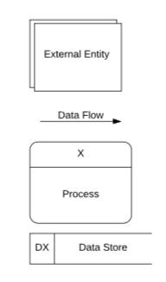

## Context Diagram



## Diagram 0

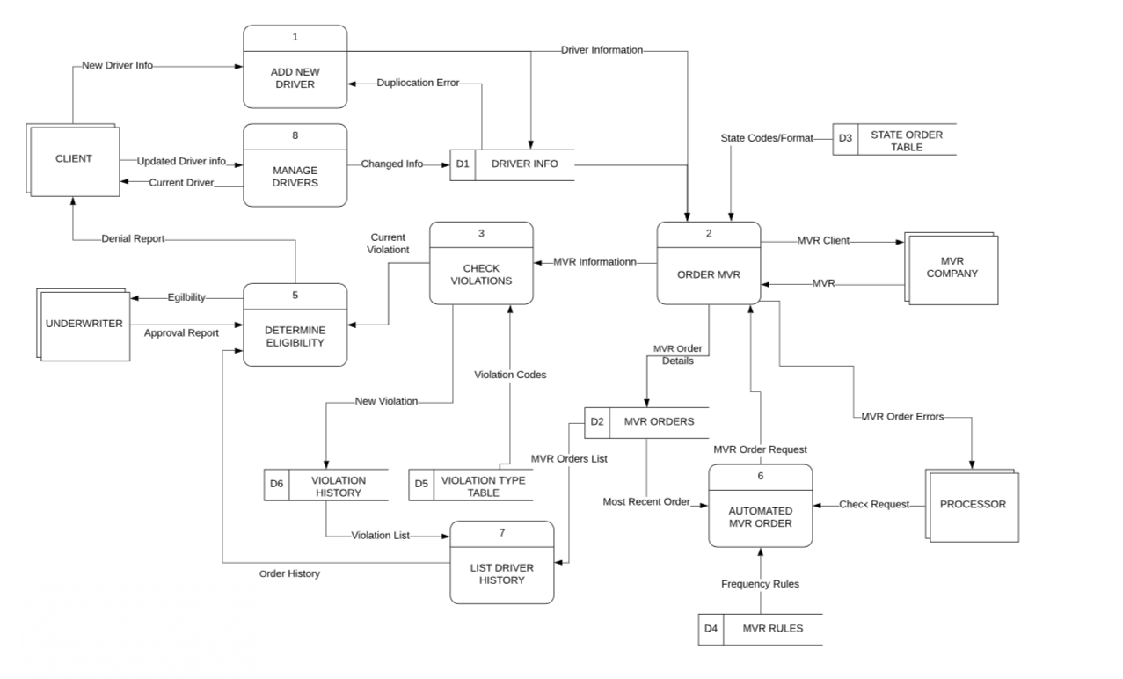

## Child Diagrams



Decomposition Diagram

/Users/jordanmoore/Documents/GitHub/igotacinit380/Phase 2/2.0.Child_Diagram.pdf

Data Dictionary

# Entity Relationship Diagram



# CRUD Matrix



# Wireframes



# Security Authorization

|  |  |  |
| --- | --- | --- |
| User-Role | Description | Security |
| Underwriter | An underwriter analyzes the risks in insurance; thus, they will need to see drivers MVRs and decide if they are an insurance risk. | An underwriter will be able to update whether a driver is allowed on a client's insurance plan. |
| Processor | A processor reviews application, collecting all necessary files and records. | A processor will be able to create, read, update, and delete drivers from a client's insurance plan. |
| Manager | A manager oversees a processor and underwriter. | A manager will be able to create, read, update, and delete anything. |
| Client | A client requests an insurance plan from Federated. | A client will be able to create, read, update, and delete drivers from their insurance plan. |

# Appendix A – Resumes



